URUMU DHANALAKSHMI COLLEGE

BHARATHIDASAN UNIVERSITY

TRICHIRAPALLI-19

NAAN MUTHALVAN SCHEME

PG-RESEARCH DEPARTMENT OF PHYSICS

TITILE : CHARTING THE COURSE OF INNOVATION: A STARTUP ANALYSIS

Team Members

1. P. Manthra
2. M. Punitha
3. M. Pricillamary
4. K. Maheshwari

INTRODUCTION:

**Starting a new company can be an exciting and rewarding experience, but it also requires careful planning and analysis to ensure that the business is viable and successful. There are several key areas that you should focus on when conducting a startup company analysis. Conducting a thorough analysis of these areas can help you identify potential challenges and opportunities, and develop strategies to address them. It is also important to regularly review and update your analysis as the business progresses, in order to adapt to changing market conditions.**

**PURPOSE:**

**Nowadays, it is no surprise that people are really finding meaning in their work more than just working for money. Similarly, as companies are challenged by the changes in their environment and often confused and led by their competition, one way to get them back on course is by seeking or redefining their purpose, and re-calibrating their compass.**

**In today's turbulent terrain, whether we are a startup, a multi-national, a department or a team, we need a beacon to leading the way, a map to showing the paths, and a compass to charting our course**

**DASHBOARD 1 :**

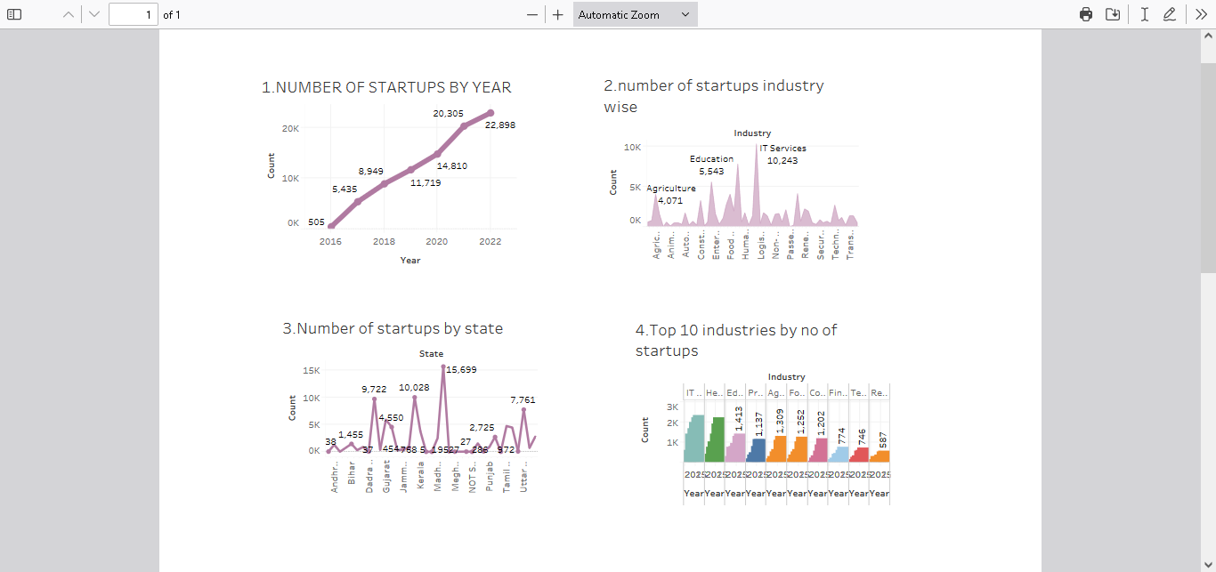

**DASHBOARD : 2**

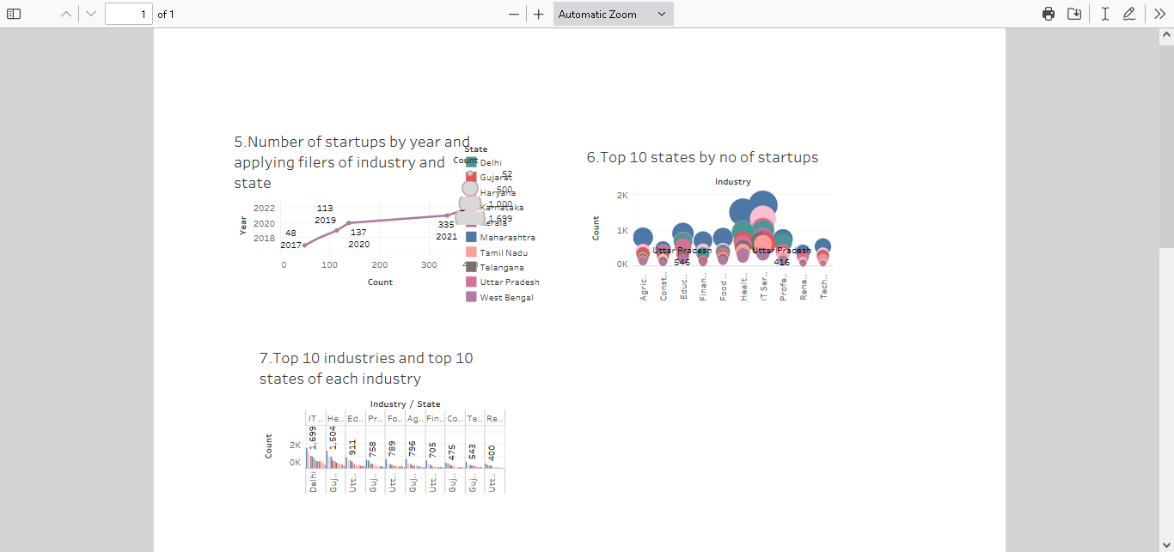

**ADVANTAGE :**

* **Improved productivity**
* **Reduced cost**
* **Increased competitiveness**
* **Improved brand recognition and value**
* **New partnerships and relationships**
* **Increased turnover and improved profitability**

**DISADVANTAGE :**

* **Very costly and time consuming**
* **Business can run out of money if they invest too much and don’t get products to market quickly enough**
* **End up wasting resources by developing something that does not sell**

**USES :**

* **Faster introduction of new products and higher launch success rates**
* **Earlier detection of non- viable ideas and better plans for implementation**
* **Improved deadline observation by creative teams**
* **greator monetary efficiency with in the creative**

STORY 1 :

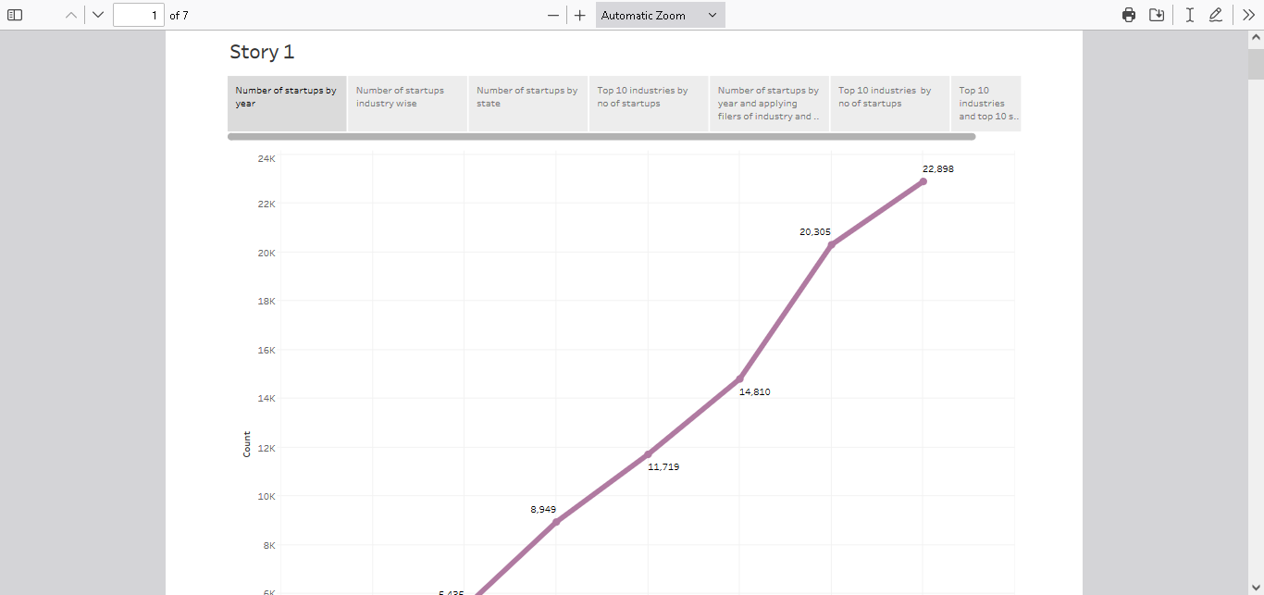

THEORY OF STORY :

To accomplish this, we have to complete all the activities listed below,

* Define Problem / Problem Understanding
  + Specify the business problem
  + Business requirements
  + Literature Survey
  + Social or Business Impact.
* Data Collection & Extraction from Database
  + Collect the dataset,
  + Storing Data in DB
  + Perform SQL Operations
  + Connect DB with Tableau
* Data Preparation
* Prepare the Data for Visualization
* Data Visualizations
  + No of Unique Visualizations
* Dashboard
  + Responsive and Design of Dashboard
* Story
  + No of Scenes of Story
* Performance Testing
  + Amount of Data Rendered to DB ‘
  + Utilization of Data Filters
  + No of Calculation Fields
  + No of Visualizations/ Graphs
* Web Integration
  + Dashboard and Story embed with UI With Flask
* Project Demonstration & Documentation
  + Record explanation Video for project end to end solution
  + Project Documentation-Step by step project development procedure

EMPATHY MAP :

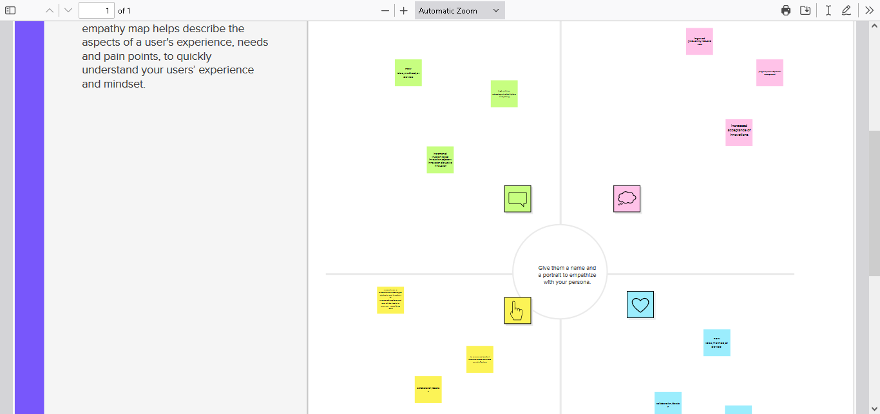

THEORY OF EMPATHY MAP :

**Summary:** Visualizing user attitudes and behaviors in an empathy map helps UX teams align on a deep understanding of end users. The mapping process also reveals any holes in existing user data.

As UX professionals, it is our job to advocate on behalf of the user. However, in order to do it, not only must we deeply **understand our users**, but we must also **help our colleagues understand** them and prioritize their needs. [Empathy maps](https://medium.com/the-xplane-collection/updated-empathy-map-canvas-46df22df3c8a), widely used throughout agile and design communities, are a powerful, fundamental tool for accomplishing both.

Definition: An **empathy map** is a collaborative visualization used to articulate what we know about a particular type of user. It externalizes knowledge about users in order to 1) create a shared understanding of user needs, and 2) aid in decision making.

This article is a guide to empathy mapping and its uses.

**Format**

Traditional empathy maps are split into 4 quadrants (*Says*, *Thinks*, *Does*, and *Feels*), with the user or persona in the middle. Empathy maps provide a glance into who a user is as a whole and are **not**chronological or sequential.

CONCLUSION :

Innovation is the result of will ful and serendipitous interconnections between the little ahas